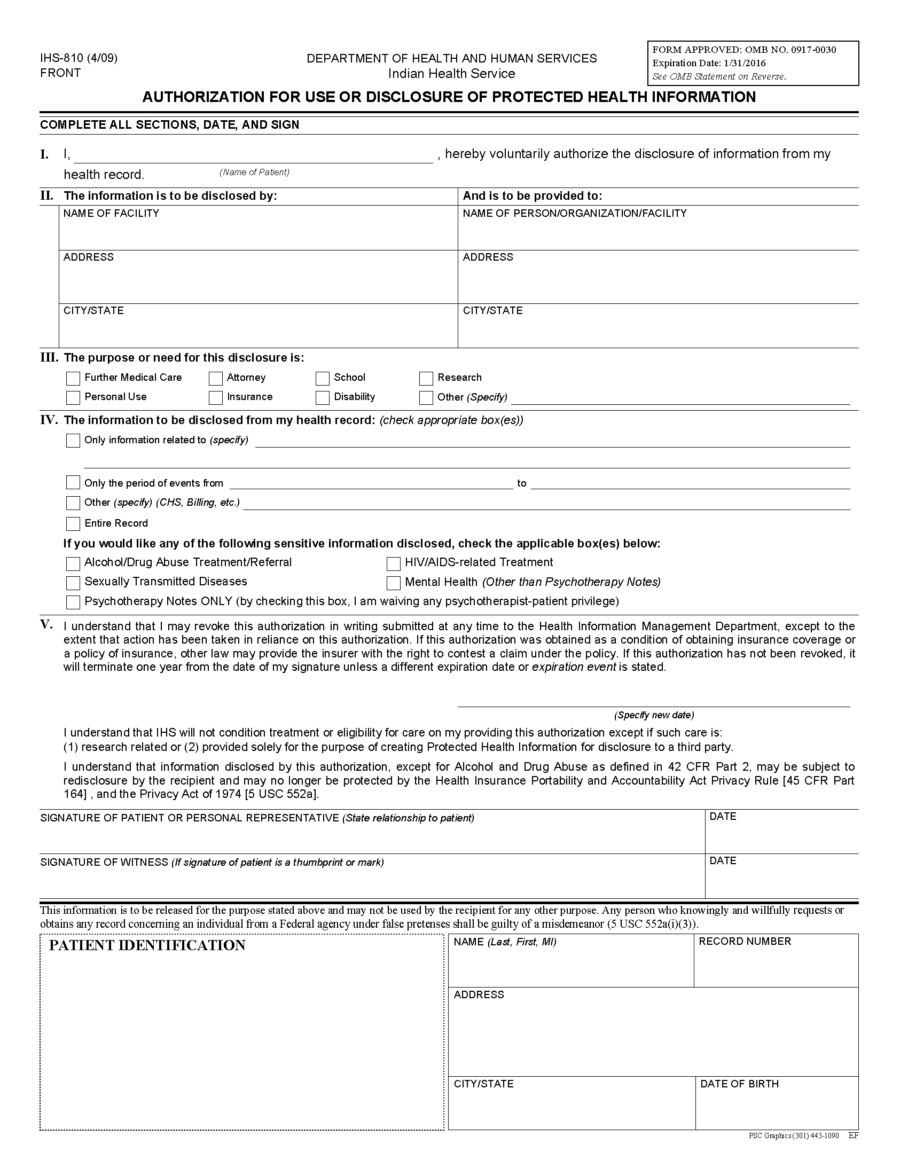
Batman
University of Michigan Hospital and Health Center
2901 Hubbard Street Release of Information Unit
Ann Arbor, MI 48109-0000
Axiom Requisition Copy Service
2869 Jolly Road
Okemos, MI 48864
x
Litigation
FROM 01/01/1979 TO PRESENT: Any and all MEDICAL RECORDS, including but not limited to patient history form(s), reports, etc. pertaining to Batman SSN: xxx-xx-5555, DOB: 01/01/1979.
Batman
Secret Location Under Office Building
Gotham, NJ
xxx-xx-5555
Order No: 01-29018-002
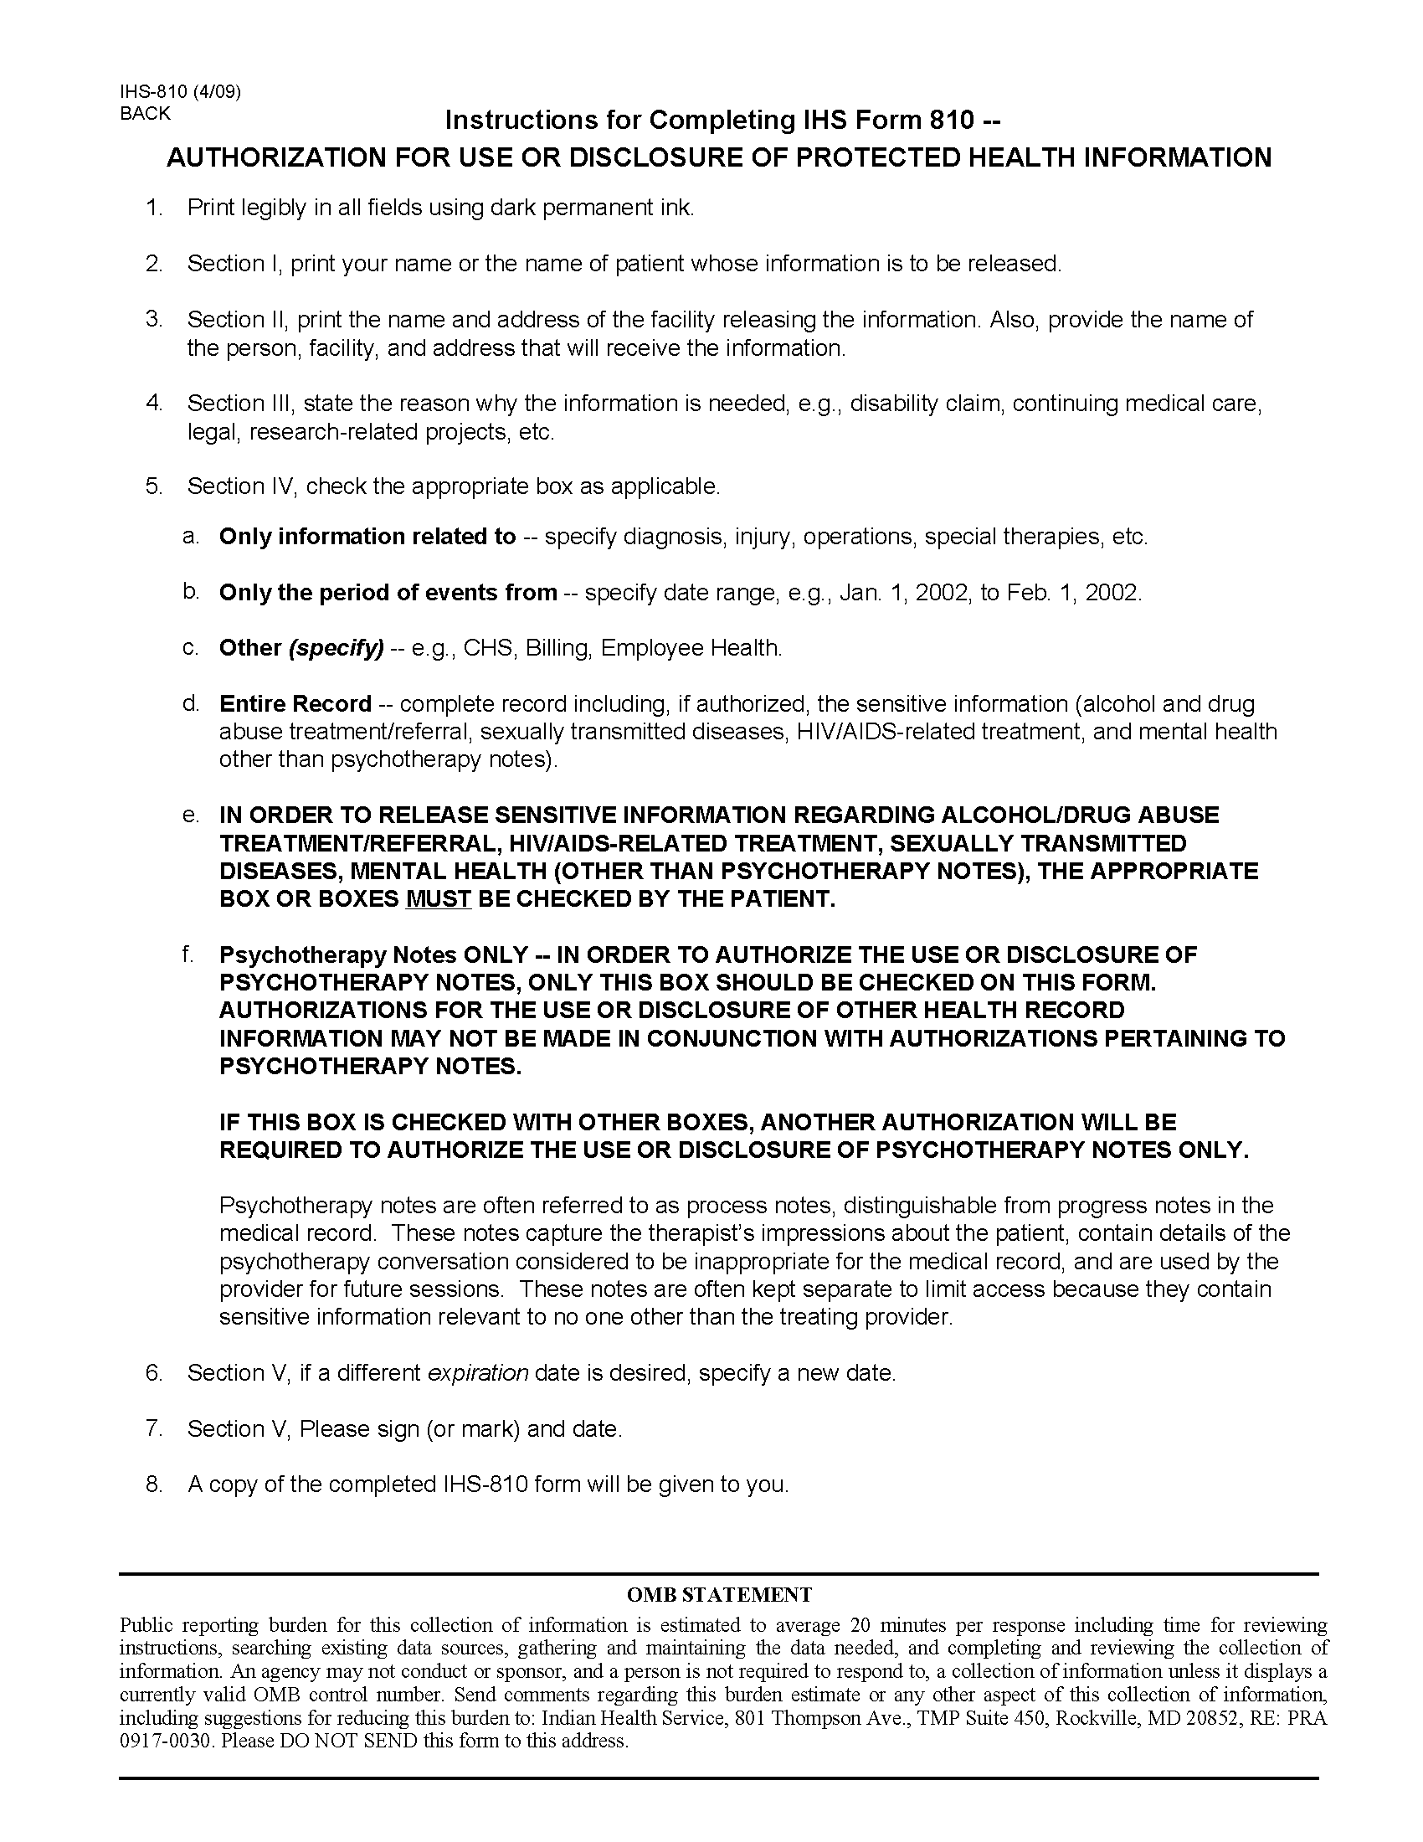
Order No: 01-29018-002

